NAME: ahmed mohamed hamed mohamed

B.N: 118

DATE:

TOPIC: artificial intelligence

APPLICATION PRIEF:

As machines become increasingly capable, tasks considered to require "intelligence" are often removed from the definition of AI, a phenomenon known as the AI effect. A quip in Tesler's Theorem says "AI is whatever hasn't been done yet." For instance, optical character recognition is frequently excluded from things considered to be AI, having become a routine technology. Modern machine capabilities generally classified as AI include successfully understanding human speech, competing at the highest level in strategic game systems (such as chess and Go, autonomously operating cars, intelligent routing in content delivery networks, and military simulations.

Artificial intelligence was founded as an academic discipline in 1955, and in the years since has experienced several waves of optimism, followed by disappointment and the loss of funding (known as an "AI winter"), followed by new approaches, success and renewed funding. For most of its history, AI research has been divided into sub-fields that often fail to communicate with each other. These sub-fields are based on technical considerations, such as particular goals (e.g. "robotics" or "machine learning"), the use of particular tools ("logic" or artificial neural networks), or deep philosophical differences. Sub-fields have also been based on social factors (particular institutions or the work of particular researchers).

SCREEN SHOTS:

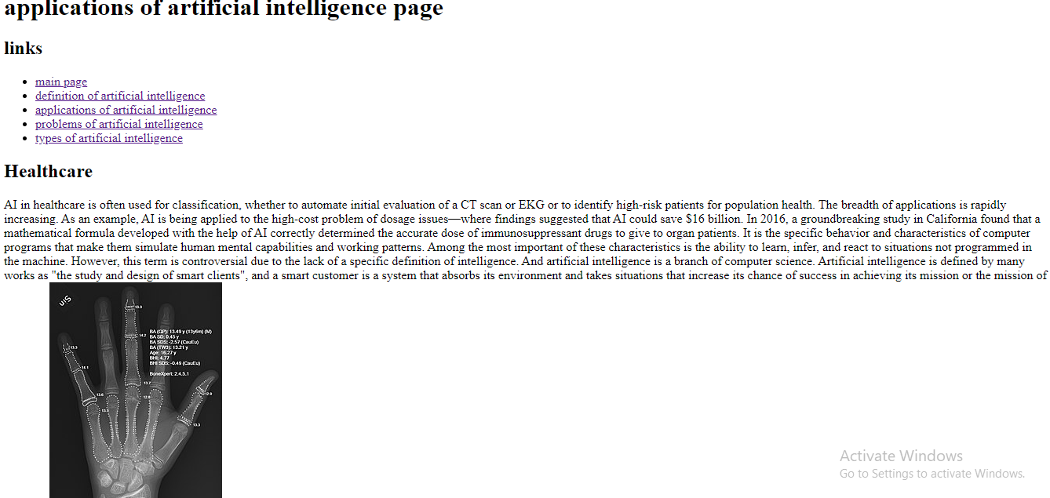

SOURCE CODE:

